

**Capability Statement**

*Reimagining the way you work*

**WHO WE ARE**

GenTech Associates is a Certified Service-Disabled Veteran-Owned Small Business, an 8(a) Small Disadvantaged Business, and a peer-reviewed, licensed CPA firm headquartered in Indianapolis, IN. We currently support more than a dozen federal and civilian agencies, including all branches of the Department of Defense, the Department of Veterans Affairs, the Department of the Interior, the Centers for Disease Control and Prevention, and the State of Indiana. GenTech is an experienced prime contractor and has successfully managed teams consisting of both large and small businesses as subcontract partners.

**Contract Vehicles**

* **GSA MAS (Professional Services) # GS-23F-053AA**
* **GSA 8a STARS III # 47QTCB21D0326**
* **Navy Seaport NxG # N00178-19-D-7696**
* **Army EXPRESS IDIQ # W31P4Q-18-A-0091 (CTA Partner)**
* **GSA OASIS Pool 1 SB and 8a (Allied Technology JV)**
* **8(a) and SDVOSB Sole Source Ability**
* **GSA OASIS+ SDVOSB**

*Visit our Website for more information*

**WHAT WE DO**

*A partial listing of our capabilities:*

* Accounting and Audit Support
* Independent Audits
* Healthcare management and IT Consulting
* Data Analytics and presentation
* Custom IT Solutions
* Acquisition / Grants management
* Administrative support
* Professional Training Solutions
* Executive Coaching
* Strategic Planning
* Organizational Analysis
* Professional and IT staffing

**OUR MISSION**

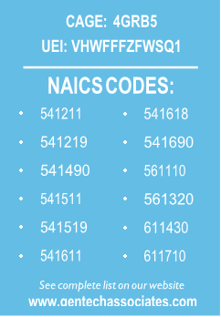GenTech possesses extensive qualifications in delivering innovative professional services that enable our government clients to address the challenges of maintaining complex organizations and achieving mission goals. We specialize in providing top-tier, Big 4-caliber accounting and management consulting support in a highly cost-effective manner. In 2022, we were named to the Inc. 5000 Annual List of America’s Fastest-Growing Private Companies for the fifth consecutive year.

**OUR CERTIFICATIONS**

* SBA-Certified 8(a) Firm
* CVE-Verified Service-Disabled Veteran Owned Small Business
* Peer Reviewed, Licensed CPA Firm (State of Indiana)
* State of Indiana Veteran Business Enterprise
* City of Indianapolis Veteran Business Enterprise
* State of Ohio Veteran-Friendly Business Enterprise
* ISO 9001:2015

